4

Drupal 7 Administration

In the last chapter, we looked at changes to the Drupal 7 content management system. In this chapter, we will look into changes that have been made to the Administration interface in Drupal 7. In addition to discussing information about the new functionality that has been added to Drupal 7, we will also discuss areas where configuration options have been moved or renamed from Drupal 6 to Drupal 7. Some of the key changes include:

* The new administration toolbar so you can quickly access different areas of the site
* The administration overlay which allows you to administer your site without losing your place on the main site
* The new shortcut functionality which gives you immediate access to commonly used commands
* Installation of modules and themes directly from your site
* The new administrator role which allows you to easily give administrators full access to the site without having to maintain permissions each time a new module is installed

And much more

At the end of this chapter, you should be able to navigate the new Drupal 7 administration interface, leverage the new administration features in Drupal 7, and easily find all of your favourite features from Drupal 7.

# New Administration interface

The most obvious change for past Drupal administrators is the completely new administration interface. In addition to just looking different, the overall structure of the administration interface has been reworked. Although the new interface does take some getting used to if you have been working with Drupal for many years, the new interface is much more productive and presents information more clearly. Let's explore each section of the administration area before looking at each specific piece of functionality.

## Administration Toolbar

The Administration Toolbar displays the major sections of the administration area and indicates which section is currently active:

\\VOODOO\Current-Titles\1223_Drupal 7 First Look\Chapter04\Graphics\1223_04_01.png

Insert image 1223\_04\_01.png

The Dashboard is a completely customizable page which allows you to set up your ideal interface for managing, monitoring, and maintaining your site.

The Content section contains everything related to listing and adding content to your site. Key information includes lists of existing content as well as lists of existing comments. If you are using the Book module, your books are also listed here. The content section also includes links to create new content.

The Structure section has information related to organizing content on your site. Some of the subsections within the Structure section include: Blocks, Content types, Forums, Menus, Taxonomy, and more.

The Appearance section allows you to select and configure the themes for your site.

The People section allows you to manage your site's users and add new users to your site.

The Modules section allows you to install and upgrade new modules from this section as well as managing the modules that are already installed.

The Configuration section gives you access to all of the administration options for many optional modules as well as standard options that do not fall into one of the other main sections. Depending on the modules you have installed, you can access a variety of subsections in the Configuration area including:

* Regional and Language: Settings related to dates, time zones, languages, and translations.
* System: Settings related to site information, actions, shortcuts, and statistics.
* User Interface: Settings related to Drupal's user interface.
* Workflow: This subsection contains tools to customize the process for creating, editing, and publishing content on the site.
* Search and Metadata: Settings related to paths, URLs, and searching.
* People and Permissions: Allows you to configure roles and permissions to determine what visitors can do on your site, and allows you to control who can access your site.
* Development: Miscellaneous settings related to logging, error reporting, performance, and monitoring.
* Web Services: Configuration for importing and exporting data as RSS information.
* Media: Settings related to the file system as well as images.
* Content Authoring: Allows you to modify options related to building content. By default, this includes the configuration of Text formats.

As new modules are installed, new settings and new subsections may be added.

The Reports section contains a variety of reports related to the operation of your website.

The Help section, as it's name implies, gives you access to online help related to the operation of your website.

At the far right of the toolbar, the active user is displayed with a link to their user information. There is also a link to Log out of the site.

Finally, there is a link  which allows you to open or close the shortcut bar.

Insert image 1223\_04\_03.png

Let's look at these sections in more detail. The changes within the Content and Structure sections were covered in the last chapter, so we will not cover them again here.

Menu and Block functionality has not changed from Drupal 6. If you need a refresher course on these topics, you can refer to any Drupal 6 book, like "Drupal 6 Site Builder Solutions", Mark Noble, Packt Publishing which I authored, or an introductory Drupal 7 book.

## Dashboard

Let's start by looking at the dashboard. The default dashboard is pretty spartan as you can see in the following image:

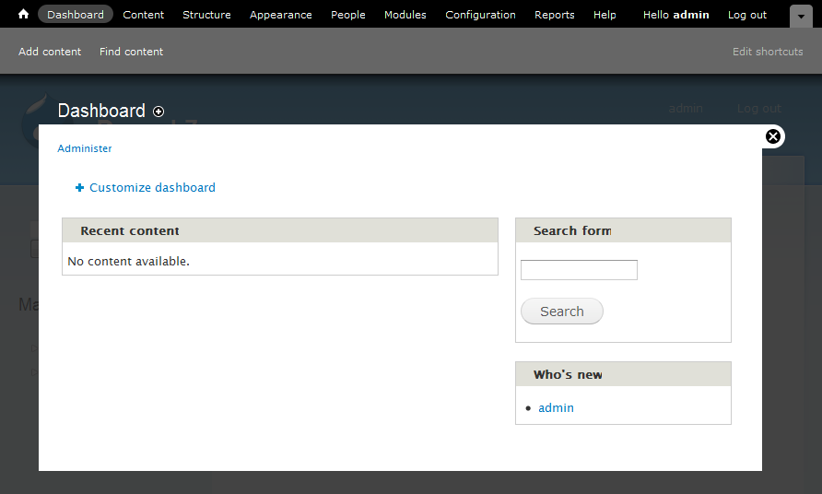

Insert image 1223\_04\_02.png

However, this spartan view belies the true power behind the dashboard. The default view contains two blocks, the management block which contains a copy of the menus that make up the top toolbar and a block with new user's to the site. Although this is an OK starting point, we can certainly make the dashboard more useful.

To customize the dashboard, click on the Customize dashboard link. This will open a new interface allowing you to modify the dashboard:

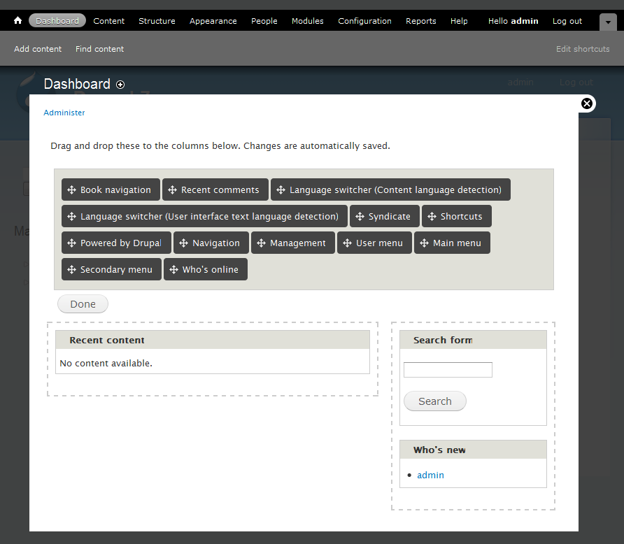

Insert image 1223\_04\_03.png

The dashboard is made up of two unequally sized regions. Each region can contain one or more blocks. Each region is outlined with dashed lines while you are customizing the dashboard. A list of all blocks that can be added to the dashboard are displayed above the regions.

To add a block to a region, drag it from the list of blocks to the region into which you want to insert it:

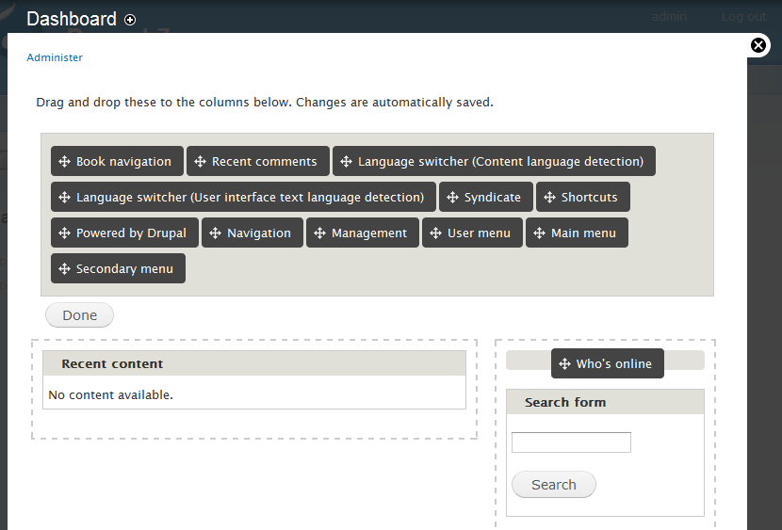

Insert image 1223\_04\_04.png

A gray bar will appear in the region showing where the block will be inserted. You can insert blocks above or below any existing blocks.

To remove a block, simply reverse the process by grabbing a block by its gray title bar and dragging it back to the list of blocks.

If you don't find a block that meets your needs in the current list of blocks, you can create a custom block. For example, you could create a short menu of commonly used links, or you could add blocks to return various statistics about your site. Let's build a quick block to display the current database size.

Start by clicking on the add a custom block link. You will be taken to the block creation page where you can enter information about the block.

Note, the add a custom block link is currently missing. See <http://drupal.org/node/556872>. After it is restored, this section should be double checked.

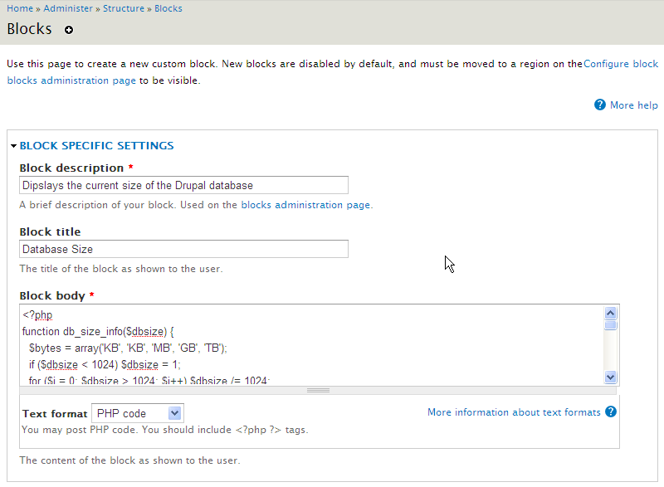

Insert image 1223\_04\_05.png

As you can see, we need to enter the title and description of the block as well as the body of the block which controls the output of the block. In this case, we set the Text format to PHP code so we can query the database.

Here is the complete text of the block body. This code is based on a code snippet from the Drupal.org site, but it has been adjusted for Drupal 7. You can find the original Drupal 6 code at http://drupal.org/node/100270.

<?php

function db\_size\_info($dbsize) {

//Load the units of measure into an array

$bytes = array('KB', 'KB', 'MB', 'GB', 'TB');

//Reduce the size of the database to the correct scale by

//dividing by 1024 until we reach a value between 1 and 1024

if ($dbsize < 1024) $dbsize = 1;

for ($i = 0; $dbsize > 1024; $i++) $dbsize /= 1024;

//Now that the size has been reduced properly, setup the

//return value and units.

$db\_size\_info['size'] = ceil($dbsize);

$db\_size\_info['type'] = $bytes[$i];

return $db\_size\_info;

}

//Load statistics from the database

$rows = db\_query("SHOW TABLE STATUS")->fetchAll();

//Loop through each row of data to calculate the total size

$dbssize = 0;

foreach ($rows as $row) {

$dbssize += $row->data\_length + $row->index\_length;

}

//Print the raw number of bytes in the database

print "$dbssize bytes ";

//Calculate and print the normalized size of the database

$dbssize = db\_size\_info($dbssize);

print "({$dbssize['size']} {$dbssize['type']})";

?>

After you have entered the appropriate information into the block, click on the Save block button. The block will be created and added to the list of available blocks. To add it to your dashboard, simply drag it into one of the available regions. The resulting dashboard will appear similar to the following:

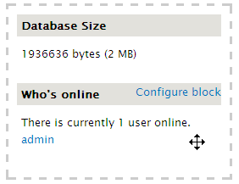

Insert image 1223\_04\_06.png

After you have finished modifying your database, click on the Done button to return to the regular view.

## Overlay window

As you may have noticed in the previous screen shots, the administration pages no longer appear in their own page. Instead, they open an overlay window which appears on top of your normal site content as shown below:



Insert image 1223\_04\_02.png

This allows you to easily return to your content after you have completed your administrative changes. You can close the overlay window by clicking on the X at the top right hand corner of the overlay panel.

## Appearance section

The Appearance section gives you control over the themes installed on your site. When you first click on the Appearance link, you are taken to a list of themes that have been installed on the site as shown on the following page:

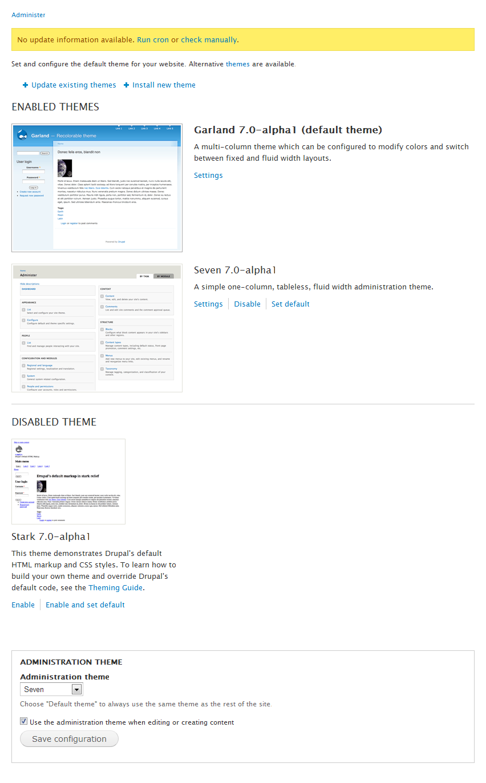

Insert image 1223\_04\_07.png

From this page, you can enable or disable themes and set the active theme which is used when displaying content. The Administration theme drop down allows you to change the theme used when administering the site. This functionality is identical unchanged from Drupal 6. In Drupal 6, you could reach this functionality by selecting Administer | Site building | Themes. Clicking on the Settings link for an enabled theme allows you to change the display of various elements within the site, set logos and shortcut icons, and so on. The exact settings that are available depend on the theme being configured. This functionality matches the Drupal 6 functionality.

### Installing and updating Themes and Modules

As you may have noticed on the list of available themes, there are links at the top of the page to Update existing theme and Install new theme. These are new features within Drupal 7, and they definitely make life easier for administrators. Let's start by looking into installing new themes and then we will review updating themes.

#### Installing new Themes and Modules

To start the installation process for a theme, click on the Install new theme link. This will display a form where you can install a theme or module as shown below:

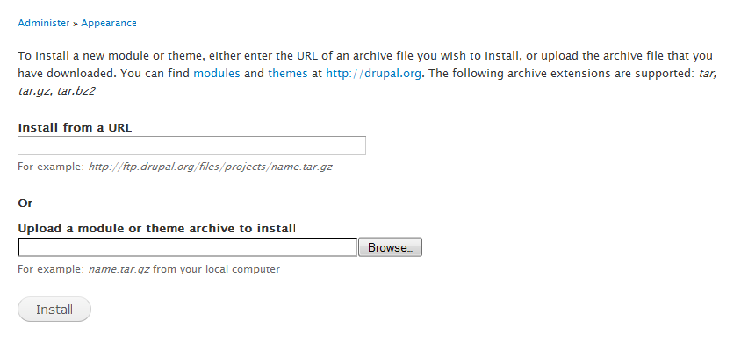

Insert image 1223\_04\_08.png

There are two different ways you can install a theme. You can either install the theme directly from the Drupal.org site, or you can upload a module from your local machine that has either been downloaded from the Drupal.org site or built locally.

To install a theme from the Drupal.org site, you will first need to visit Drupal.org and find a theme that you want to use. After you have found a theme, visit the project page for the theme. Scroll down to the releases section and right click on the Download link:

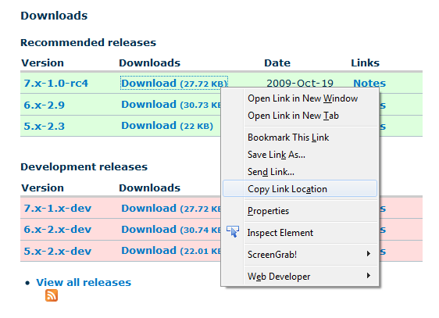

Insert image 1223\_04\_10.png

From the pop-up menu, select Copy Link Location if you are using Firefox or Copy Shortcut if you are using Internet Explorer. Other browsers will have similar options. This will copy the path to download the theme to your clipboard. Now switch back to your site and paste the link into the Install from a URL text box. After you have set the URL you want to install, click on the Install button. Drupal will automatically download the theme and install it onto your site. During this process, the status of the installation will be shown. After the installation is complete, you will receive a status page similar to the following:

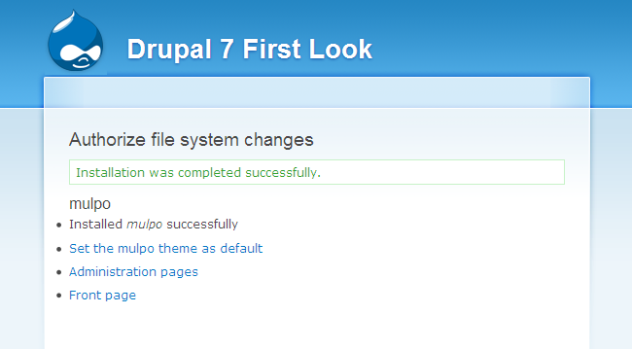

Insert image 1223\_04\_11.png

From this status page, you can make the new theme your default theme or you can return to either the Administration interface or your front page.

Installing from a downloaded package is similar to installing directly from a URL with a few exceptions. After finding a theme that you like, download it to your local computer instead of simply copying the download link. You can then browse for the location of the module on your local computer. You will need to click on Install to start the installation process.

This functionality can also be used to install modules. The process is exactly the same as installing a theme and the status page is very similar.

#### Updating Themes (and Modules)

When you click on the Update existing modules link, Drupal will display a list of any modules that have updates available:

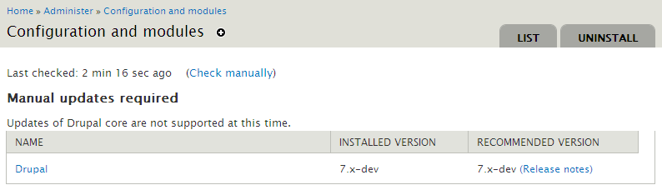

Insert image 1223\_04\_12.png

If any modules or themes have updates, you can install them from this page. You can also check for updates manually if the system has not automatically checked for updates recently.

## People section

The People section allows you view and manage the users within your site and appears as follows:

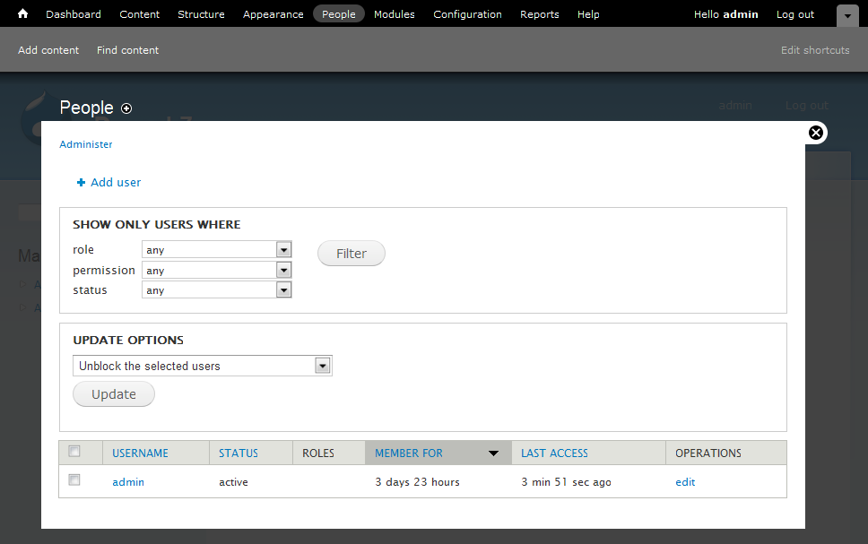

Insert image 1223\_04\_13.png

The functionality on this page is identical to the Drupal 6 functionality which could be reached from Administer | User Management | Users. From this page, you can add new users administratively. You can also block users, completely cancel their account, or add and remove roles assigned to them.

## Modules section

The Modules section allows you to determine which modules are active on your site, and install new modules on your site. All modules that have been installed on your site appear in a categorized list as shown in the following image:

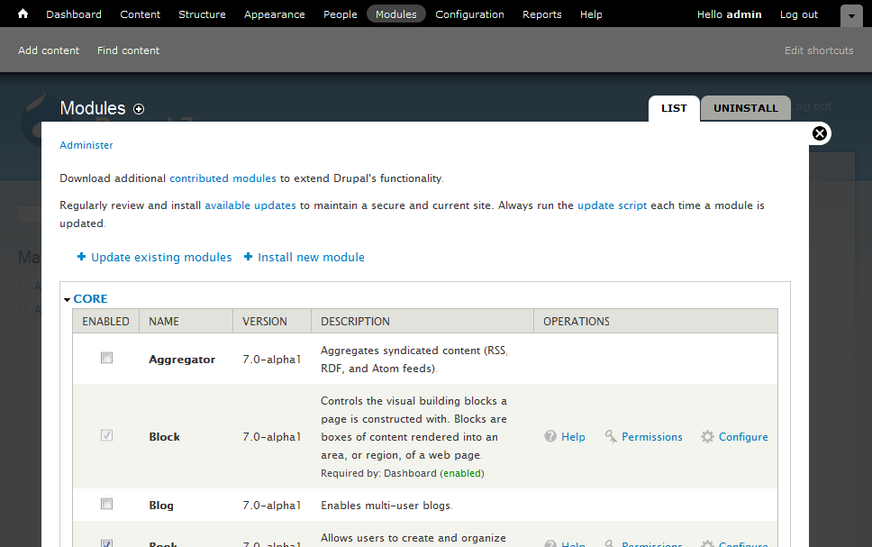

Insert image 1223\_04\_17.png

To enable the module, simply select the check box next to the module you want to enable and then click on Save configuration at the bottom of the page. To disable the module, simply deselect the check box and then click on Save configuration.

Some modules have an uninstall process that cleans up the database or associated files. You can access the uninstall process by clicking on the Uninstall tab. Only uninstall a module if you are certain you will not use it in the future.

Drupal 7 also includes the ability to install a module either directly from the Drupal.org website or from a downloaded installation package. The process for doing so is exactly the same as the process for installing themes which we covered earlier in the chapter.

You can also access configuration settings for a module directly from the list of modules, change permissions for an individual module, and get additional help for a module. All of these options may or may not be shown depending on the module in question.

## Configuration section

The Configuration section contains the bulk of the settings you will need to properly set up your website. The main interface appears as follows:

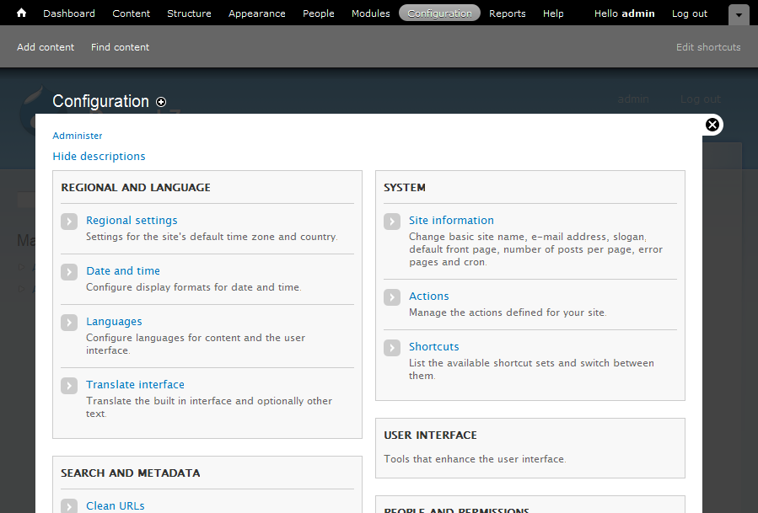

Insert image 1223\_04\_14.png

Because many different modules add their settings to this configuration page, the actual options which appear will vary depending on the modules you have activated for your site. For purposes of review, I have enabled all of the Drupal modules that are available in Drupal core.

### Configuring settings

The majority of the settings are the same from Drupal 6 to Drupal 7. Let's look at each set of settings in Drupal 7. For each group of settings, we will identify the new Drupal 7 path and the old Drupal 6 path and menu descriptions. We will also provide a brief description of the settings contained within that section and list any settings that have been added or removed.

#### Regional and Language

This section contains settings that you may need to change based on the geographic location of your site or the language(s) in which your site is written.

##### Regional settings

Drupal 7 Path: admin/config/regional/settings

Drupal 6 Menu Location: Administer | Site configuration | Date and Time

Drupal 6 Path: admin/settings/date-time

Description: contains settings for the default time zone for the site, whether or not users can set their own time zone, the default country, and the first day of the week.

New Settings: Drupal 7 adds the ability to remind users to set a time zone if they haven't set the time zone yet, and how the time zone should be handled when new users register on the site. Drupal 7 also adds the ability to set the default country for the site.

##### Date and time

Drupal 7 Path: admin/config/regional/date-time

Drupal 6 Menu Location: Administer | Site configuration | Date and Time

Drupal 6 Path: admin/settings/date-time

Description: contains settings related to the display of dates in various formats.

New Settings: Administrators that run multi-lingual sites will love all of the new settings related to Dates and Times. You can now format dates differently depending on which language a user has active. You can also define custom formats for date formatting. We will review all of this new functionality a little later in the chapter.

##### Languages

Drupal 7 Path: admin/config/regional/language

Drupal 6 Menu Location: Administer | Site configuration | Languages

Drupal 6 Path: admin/settings/language

Description: Allows configuration of which labels are available to site users for display on the site.

New Settings: Drupal 7 allows additional control over how the system detects which language should be used when displaying content to users. Drupal 7 also gives you the ability to control the language used to display labels independently from the language used to display content. We will review all of these changes in more detail later.

##### Translate interface

Drupal 7 Path: admin/config/regional/translate

Drupal 6 Menu Location: Administer | Site building | Translate interface

Drupal 6 Path: admin/build/translate

Description: The translation settings allow you to translate information within the Drupal interface. To speed up the translation process, you can import translation files and you can also export information to be translated.

New Settings: The translation interface has been updated in a few locations to make it more compact and easier to use, but the actual functionality has not been changed from Drupal 6.

#### Search and Metadata

##### Clean URLs

Drupal 7 Path: admin/config/search/clean-urls

Drupal 6 Menu Location: Administer | Site configuration | Clean URLs

Drupal 6 Path: admin/settings/clean-urls

Description: Allows you to determine how URLs should be formed.

New Settings: The overall look has changed slightly, but the functionality remains the same.

##### Search settings

The search settings section contains settings related to how URLs appear on your site as well as giving you control over the actual search engine.

Drupal 7 Path: admin/config/search/settings

Drupal 6 Menu Location: Administer | Site configuration | Search Settings

Drupal 6 Path: admin/settings/search

Description: Provides configuration options related to searching including the status of search indexing, the ability to index the site, determine how the site should be indexed, and how the indexing should work.

New Settings: Drupal 7 adds the ability to determine which search modules are active and allows you to enable or disable searching Nodes and Users independently. Drupal 7 also adds Content is sticky at top of lists and Content is promoted to the front page and removes Recently posted as content weighting factors.

##### URL aliases

Drupal 7 Path: admin/config/search/path

Drupal 6 Menu Location: Administer | Site building | URL aliases

Drupal 6 Path: admin/build/path

Description: Allows you to add aliases for paths in the system so that they can be more easily entered by visitors or to improve search engine rankings.

New Settings: There have been no changes from Drupal 6 to Drupal 7.

#### Development

The development section gives you access to settings that allow you to get more information about the workings of your site as well as allowing you to monitor and configure performance related settings. You can also access the automated test system from this section.

##### Logging and errors

Drupal 7 Path: admin/config/development/logging

Drupal 6 Menu Location: Administer | Site configuration | Logging and alerts | Database Logging

Drupal 6 Path: admin/settings/logging/dblog

Description: Controls what information is logged to the database as well as how much data is kept at any one time.

New Settings: Drupal 7 adds the ability to log PHP messages to the Drupal log. The new options are as follows:

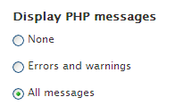

Insert image 1223\_04\_15.png

##### Maintenance mode

Drupal 7 Path: admin/config/development/maintenance

Drupal 6 Menu Location: Administer | Site configuration | Site maintenance

Drupal 6 Path: admin/settings/site-maintenance

Description: Allows you to close the site temporarily while running maintenance tasks or upgrading the site.

New Settings: This functionality is unchanged from Drupal 6.

##### Performance

Drupal 7 Path: admin/config/development/performance

Drupal 6 Menu Location: Administer | Site configuration | Performance

Drupal 6 Path: admin/settings/performance

Description: Contains settings that can influence the overall performance of your site including caching information and combining files to reduce the amount of data that must be transmitted.

New Settings: Aggressive page caching was removed in Drupal 6. This was done to reduce confusion and to remove the chance of side effects occurring. The page compression setting has also been removed if the server already compresses requests. The page has also been reformatted to make it easier to understand and use.

##### Testing

Drupal 7 Path: admin/config/development/testing

Drupal 6 Menu Location: n/a

Drupal 6 Path: n/a

Description: This link takes you to the automated testing system where you can run Drupal's built in tests as well as any tests you have written for your own module. This functionality was not available in Drupal 6 except as the Simple Test contributed module.

#### Media section

This section of configuration options contains links to settings which control how images and files are treated within your site.

##### File system

Drupal 7 Path: admin/config/media/file-system

Drupal 6 Menu Location: Administer | Site configuration | File system

Drupal 6 Path: admin/settings/file-system

Description: Gives you control over where files are stored on your server as well as how files are accessed.

New Settings: Drupal 7 now allows you to use both a public and private file system concurrently. Therefore, rather than selecting which method you would like to use, you simply select the default download method you wish to use.

#### Image styles

Drupal 7 Path: admin/config/media/image-styles

Drupal 6 Menu Location: n/a

Drupal 6 Path: n/a

Description: Allows you to configure automatic resizing and processing of images that have been added to the site. This is all new functionality in Drupal 7 which we covered in detail in the last chapter.

##### Image toolkit

Drupal 7 Path: admin/config/media/image-toolkit

Drupal 6 Menu Location: Administer | Site configuration | Image toolkit

Drupal 6 Path: admin/settings/image-toolkit

Description: Allows you to choose and configure image toolkits for the site. The default GD toolkit allows you to configure the image quality for JPEG images when the images are manipulated.

New Settings: This functionality has not changed from Drupal 6.

#### System section

The system section of settings gives you links to containing information about your site as well as allowing you to configure information about the site as well as configuration of the administration of the site.

##### Site information

Drupal 7 Path: admin/config/system/site-information

Drupal 6 Menu Location: Administer | Site configuration | Site information

Drupal 6 Path: admin/settings/site-information

Description: Gives you the ability to configure basic information about your site including the site name, site e-mail, default home page, and so on.

New Settings: In Drupal 7, the Mission and Footer message fields have been removed. You can replicate these settings using custom blocks. Drupal 7 also adds the ability to configure pages to display when a page is not found (error 404), or when a user does not have access to functionality (error 403). This can be very useful if you want to send user's to a login page or to a site map. Drupal 7 also adds a setting for the frequency to automatically run cron. We will discuss cron the new cron system in more detail later in this chapter.

##### Actions

Drupal 7 Path: admin/config/system/actions

Drupal 6 Menu Location: Administer | Site configuration | Actions

Drupal 6 Path: admin/settings/actions

Description: Allows you to build and manage actions within the system. Actions are specific individual tasks that the system performs. Actions can be run by other modules including the Trigger module when a specific circumstance arises. Actions can be either basic actions or complex actions that require configuration.

New Settings: The basic actions functionality has stayed the same in Drupal 7. However, there are several new actions that are provided in the default installation including:

* Publish comment
* Unpublish comment
* Save comment
* Publish content

Unpublish content

The names of actions related to nodes were also changed to refer to content rather than posts. We will cover changes to creating custom actions in Chapter 7.

##### Shortcuts

Drupal 7 Path: admin/config/regional/system/shortcut

Drupal 6 Menu Location: n/a

Drupal 6 Path: n/a

Description: Allows you to build shortcuts for display in the new shortcuts bar.

New Settings: This is new Drupal 7 functionality. We will review this functionality in depth a little later in this chapter.

##### Statistics

Drupal 7 Path: admin/config/system/statistics

Drupal 6 Menu Location: Administer | Reports | Access log settings

Drupal 6 Path: admin/reports/settings

Description: Allows you to control whether or not page visits are logged and how long log entries should be preserved. Also allows you to increment a counter when content is viewed.

New Settings: The display of these settings has been changed slightly, but the actual functionality remains the same.

#### People and Permissions section

This section gives you access to settings related to site visitors including what they can do on the site, and what information the system stores about site visitors.

##### Account settings

Drupal 7 Path: admin/config/people/accounts

Drupal 6 Menu Location: Administer | User management | User settings

Drupal 6 Path: admin/user/settings

Description: Allows you to configure how visitor registrations are handled on the site, automated e-mails that are sent to users, additional information about users, and more.

New Settings: The user accounts settings have changed substantially from Drupal 6. In Drupal 7, users can have fields and you can configure what happens when a user account is disabled. We will review these changes thoroughly in just a few pages.

##### Roles

Drupal 7 Path: admin/config/people/roles

Drupal 6 Menu Location: Administer | User management | Roles

Drupal 6 Path: admin/user/roles

Description: Lists active roles on the site, allows you to create new roles, and assign permissions to roles.

New Settings: This functionality remains the same in Drupal 7.

##### Permissions

Drupal 7 Path: admin/config/people/permissions

Drupal 6 Menu Location: Administer | User management | Permissions

Drupal 6 Path: admin/user/permissions

Description: Allows you to set permissions by role. All permissions are listed with all applicable roles.

New Settings: Additional descriptive information about each role has been added. However, the base functionality is the same as Drupal 6.

##### IP address blocking

Drupal 7 Path: admin/config/people/ip-blocking

Drupal 6 Menu Location: Administer | User management | Access rules

Drupal 6 Path: admin/user/rules

Description: This page allows you to block certain computers based on IP address.

New Settings: The functionality of this page was migrated partially from the access rules in Drupal 6. In Drupal 7, you cannot block entire ranges of IP addresses. If you need to block a large number of IP addresses, you should block them either in an .htaccess file or in your firewall. The new page appears as follows:

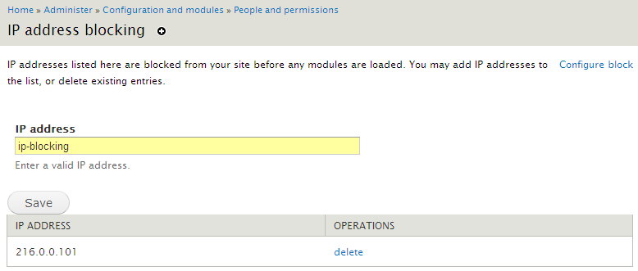

Insert image 1223\_04\_16.png

##### Profiles

Drupal 7 Path: admin/config/people/profile

Drupal 6 Menu Location: Administer | User management | Profiles

Drupal 6 Path: admin/user/profile

Description: Allows you to add information to a user's profile page. Each field can be configured to control who has access to view the field. This allows sensitive information to be stored in a way that modules and themes cannot access the information.

New Settings: This functionality has not changed from Drupal 6. However, if you do not need the additional access control that profiles provide, you should consider using fields to store the information.

#### Web Services

This section gives you access to configuration options that allow you to control how your site sends and receives standardized content on the web.

##### Feed aggregator

Drupal 7 Path: admin/config/services/aggregator

Drupal 6 Menu Location: Administer | Content management | Feed aggregator

Drupal 6 Path: admin/content/aggregator

Description: Allows you to add and categorize news feeds for display on your site.

New Settings: The aggregator settings are largely the same. However, the interface for listing the current categories and feeds includes links to create new categories and feeds. In Drupal 6, these links appeared as additional tabs. In Drupal 7, you can also configure the number of items to show in a recent news items block as well as the length to trim postings to when showing teasers. Finally, you can import OPML files to setup multiple feeds at once.

##### RSS publishing

Drupal 7 Path: admin/config/services/rss-publishing

Drupal 6 Menu Location: Administer | Content management | RSS publishing

Drupal 6 Path: admin/content/rss-publishing

Description: Allows you to publish RSS feeds of your content so it can be used on other sites.

New Settings: Drupal 7 adds the ability to enter a description for your feed. All other functionality remains the same as Drupal 6.

#### Content Authoring

This section contains settings which relate to how content is stored in Drupal, and how it is presented to your site visitors.

##### Text formats

Drupal 7 Path: admin/config/content/formats

Drupal 6 Menu Location: Administer | Site configuration | Input formats

Drupal 6 Path: admin/settings/filters

Description: Allows you to control what information can be entered into your site. You can allow specific tags or force the user to enter plain text only.

New Settings: Text formats have changed quite a bit from Drupal 6 Input formats. We reviewed all of the changes in the last chapter.

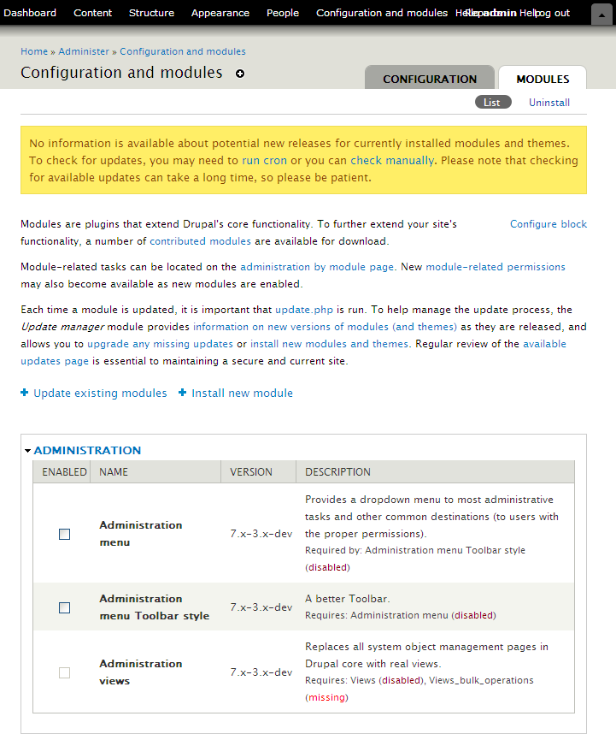

## Shortcuts

The new Drupal 7 shortcut bar can be accessed by clicking on the drop down arrow at the top right of the screen. The shortcut bar appears as follows by default:



Insert image 1223\_03\_04.png

By default, all users will share the same shortcuts. However, you can add additional sets of shortcuts. To configure the Shortcuts, click on the Shortcuts link from the Configuration and modules section.

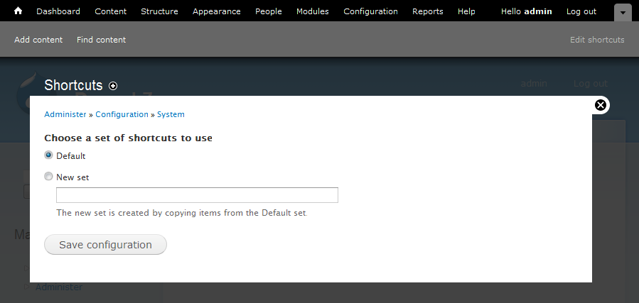

Insert image 1223\_04\_18.png

From this screen, you can switch between different shortcut sets (if you have more than one in the system), or you can create new shortcut sets. To create a new set of shortcuts, simply enter a new name and then select the Save configuration link. You will now be taken to a screen where you can configure which shortcuts are in the set. The following image shows the result of creating a new set of shortcuts called "Content Editor Shortcuts":

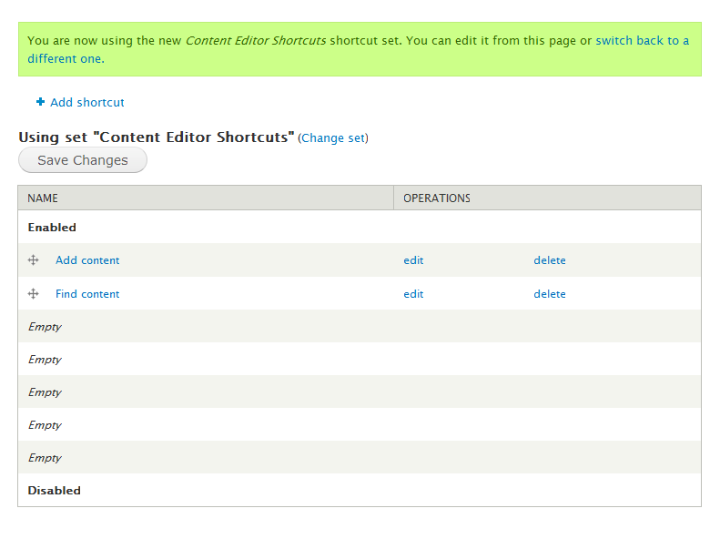

Insert image 1223\_04\_19.png

You can also reach the customization screen by clicking on the Edit shortcuts button at the top right hand corner of the shortcut bar. Each set of shortcuts can have up to 8 links within it. To add a shortcut, click on the Add shortcut link. You will be prompted for a Name and Path for the shortcut:

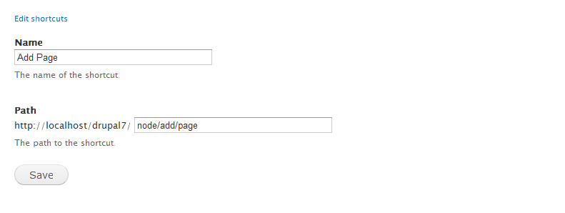

Insert image 1223\_04\_20.png

After you have entered the information to you satisfaction, click on the Save button.

This process can be a little more time consuming since you need to find the correct paths for each shortcut you want to add. To make things easier, you can also click on one of the + icons that appear throughout the site:



Insert image 1223\_04\_21.png

## Edit Anywhere

You may have noticed a Configure Block link in several of the screen shots for this chapter and the previous chapter. For example, the Configure block link appears in the help text on the Search settings page:

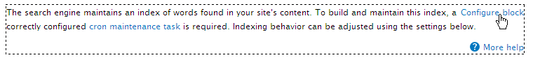

Insert image 1223\_04\_22.png

Depending on the theme you have installed, the appearance of the Configure block link may look different, and may only appear if you mouse over a block.

When you put your mouse over the Configure block link, the extents of the block will be surrounded with a dashed line so you can easily tell what you are working with. If you click on the link, you will be taken to the edit page where you can make any needed changes to the block including changing visibility, changing titles, and so on.

This functionality is part of the new edit anywhere functionality that has been added to Drupal 7. In Drupal 6, a few themes, such as Zen, implemented similar functionality, but now you can take advantage of this functionality in any theme. Edit anywhere is not just limited to blocks either. You can also edit menus directly.

# Configuring Date and Time Display

In the last section, we noted that the Date and Time configuration settings have changed from Drupal 6 to Drupal 7. Let's look into the changes in more detail.

The first tab on the Date and time settings page allows you to configure the date types that are available within the system. By default, there are three types available: Long, Medium, and Short.

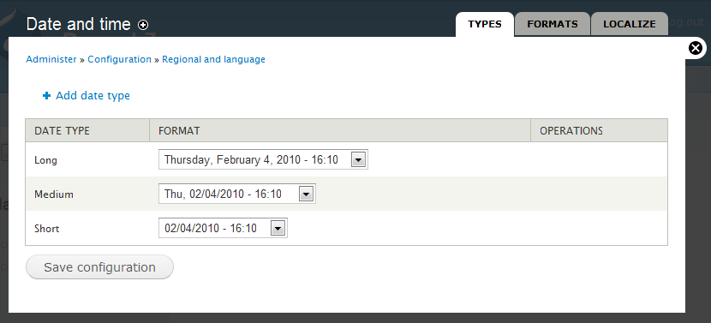

Insert image 1223\_04\_23.png

You can add a new date type by clicking on the Add date type link. Let's build an Extra Long date type. On the Add date type screen, simply enter the name of the type (Drupal will create an internal name for you) and select the Date format you want to use from the list of available formats.

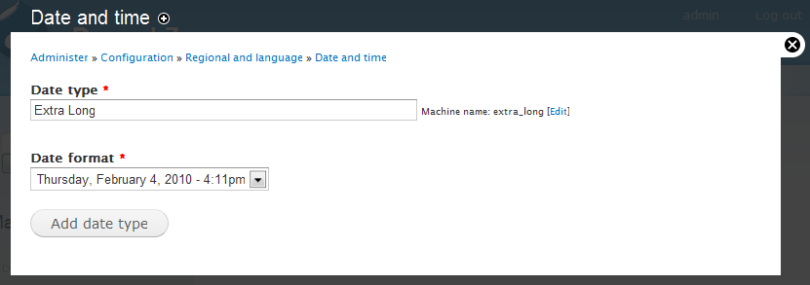

Insert image 1223\_04\_24.png

Click on the Add date type button when you are satisfied with your selections.

If you can't find the format you want in the list, you can now build your own date format. Click on the Formats tab and you will see a list of all the custom date formats which have been defined. By default, there aren't any.

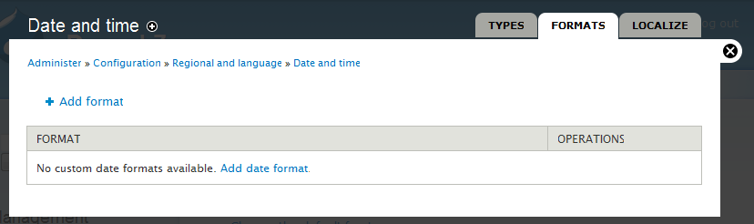

Insert image 1223\_04\_38.png

To add a new date format, click on the Add format or Add date format link. Let's build a date format that's very verbose, as shown below:

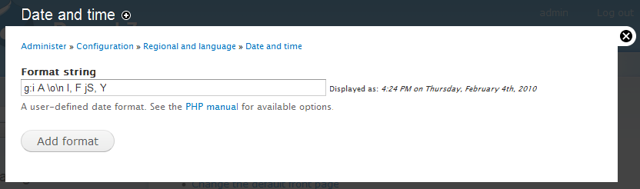

Insert image 1223\_04\_25.png

As you enter the format, Drupal will automatically display a sample representation of the format so you can verify that the format works as expected. After you are positive that the format works properly, click on the Add format button. Your new format will now be available for use on the Date types screen.

Also new to Drupal 7 is the ability to set date and time formats by language if you are running a multilingual site. This functionality is reached through the Localize tab:

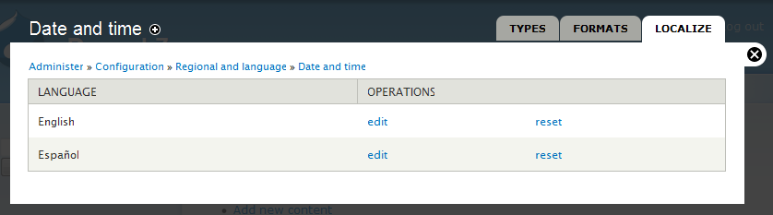

Insert image 1223\_04\_26.png

The languages that are available on this page are defined in the Languages page in the Configuration section. This page is available at http://yoursite.com/admin/config/regional/language.

To change the date formats for a particular language, simply select the edit link for the language. This takes you to a screen where you can override the default settings for a date type:

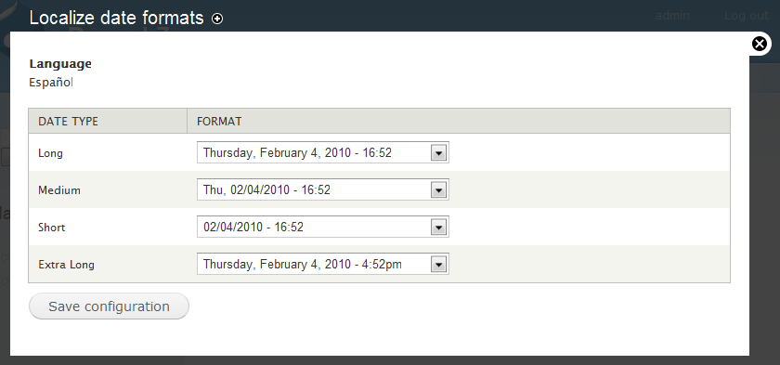

Insert image 1223\_04\_27.png

Typical changes here will include changing the order of the month and day and changing the format of the time to match the formatting which site visitors expect.

# User Management

The user management module also received a significant amount of attention in Drupal 7. The interface has been made easier to use, more secure, and more powerful.

## Account Settings

As discussed previously, the user account settings have been significantly revised and enhanced. Let's look at each section of the Account settings configuration section in detail:

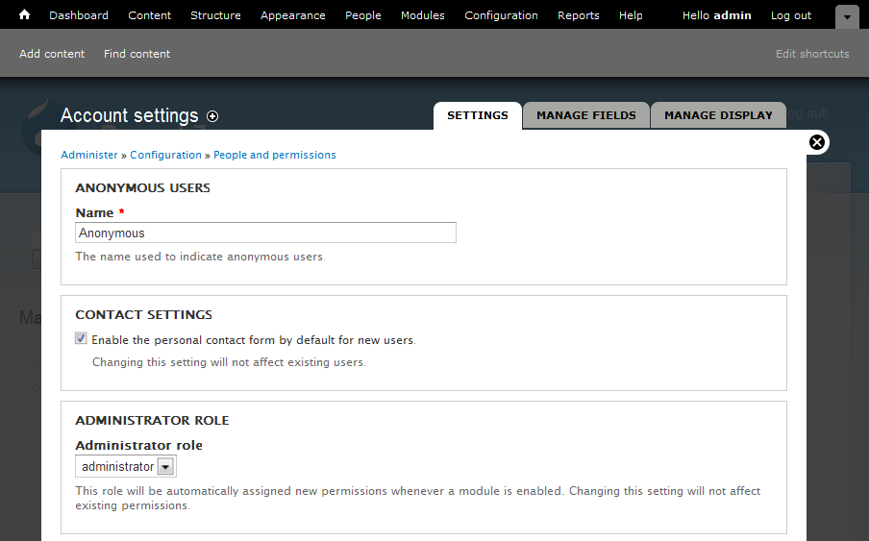

Insert image 1223\_04\_28.png

The Anonymous Users setting and Contact Settings are carryovers from Drupal 6 and serve the same function. The Administrator Role setting is brand new in Drupal 7. This setting allows you to define a role that automatically has all permissions enabled for it. The Drupal installer creates an administrator account for you. You can also change this to any other role within the system here. When you change the administrator role, the new role will automatically have all new permissions assigned to it when modules are enabled. You can also set the Administrator role to disabled which will prevent Drupal from automatically altering any roles.

If you change the administrator role, make sure to review the permissions for both the old role and the new role. Drupal does not modify any permissions when changing the administrator role so you may need to enable or disable some permissions.

Let's look at the next section now, the Registration and Cancellation settings:

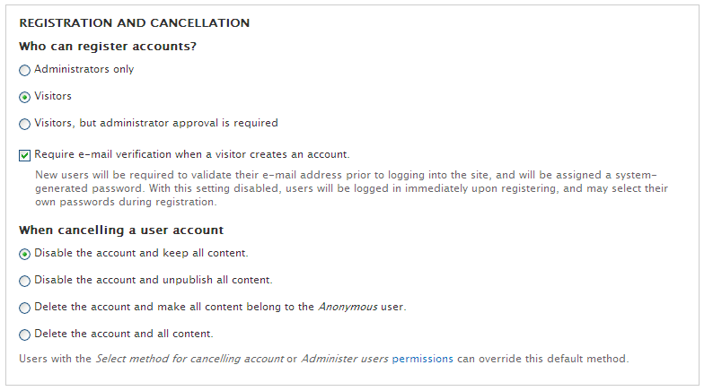

Insert image 1223\_04\_29.png

The registration settings remain the same from Drupal 6. However, the cancellation settings are brand new in Drupal 7. These settings allow you to determine what actions Drupal takes when a user cancels their account or when an administrator cancels a user's account. You have options to either disable or completely remove a user's account with a variety of options for dealing with any content the user created.

The ability for a user to cancel their own account is also new in Drupal 7. To allow a user to cancel their own account, you will need to give them permissions to do so.

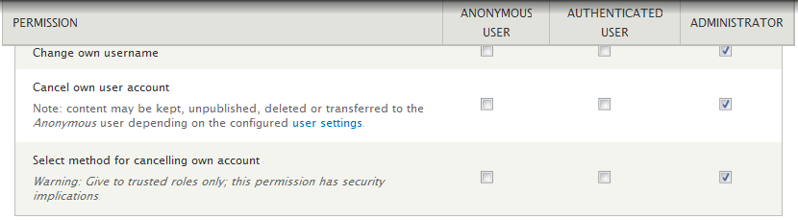

Insert image 1223\_04\_30.png

The relevant permissions are Cancel own user account and Select method for canceling own account. Depending on your site, you may want to enable these permissions for Authenticated users.

The next section within the Account settings is Personalization:

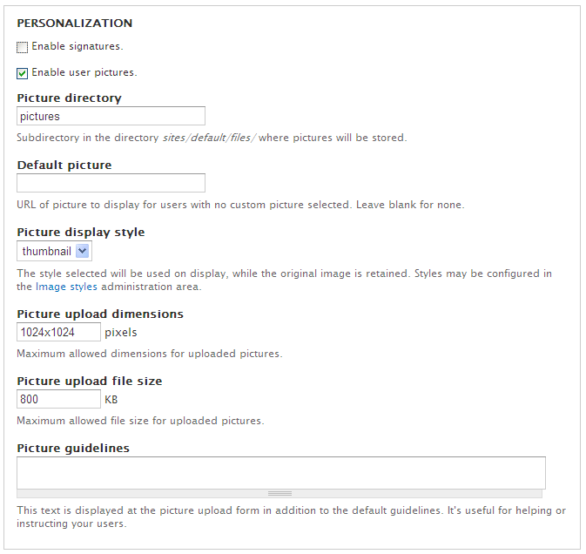

Insert image 1223\_04\_31.png

These settings remain unchanged from Drupal 6 other than a few default settings have changed. For example, user pictures are enabled by default and the default maximum size of pictures has been increased.

The final section is the E-mails section. This section has been reformatted so it is much more compact and easier to read:

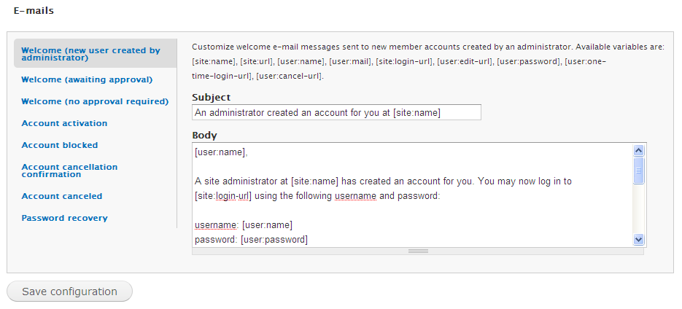

Insert image 1223\_04\_32.png

New settings for generating e-mails to users when their account is canceled or about to be canceled have been added. The remaining e-mails remain the same.

## User Fields

Similar to Content Types, Comments, and Taxonomies, Users can also have fields in Drupal 7. This is functionality is similar to the Drupal 6 Profile module. However, fields do not have the same level of control over the visibility of individual fields that the Profile module gives. In general, you should use fields unless you need strict control over who can access the data.

Fields are added in exactly the same manner used to add them to content types, comments, taxonomies, and so on.

## Password Strength Meter

When new users are created in the system either by an administrator or by a site visitor, a new password strength meter is displayed to help users ensure that their password cannot be guessed easily:

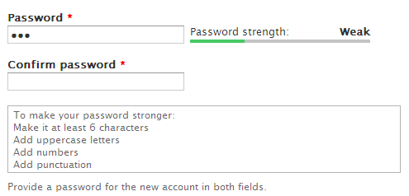

Insert image 1223\_04\_33.png

As the user enters their desired password, the system will analyze the password and suggest ways to make it more difficult to guess.

## Login rate limitations

Drupal core now includes a mechanism to help protect against brute force login attempts. The system will prevent users from logging in if they provide an incorrect password for their user name five times in six hours. The system will also prevent any IP address from logging in if that IP address is responsible for 50 failed login attempts in one hour. If these criteria are met, the user will be informed that their login attempt has failed and they will be taken to a page where they can request a new password.

The settings for the login rate limiter were carefully chosen and should work for a majority of sites. However, if your users are having problems logging in or if you find yourself wanting to lower these thresholds, you can modify the following settings:   
user\_failed\_login\_ip\_limit, user\_failed\_login\_ip\_window, user\_failed\_login\_identifier\_uid\_only, flood\_control\_user\_identifier, user\_failed\_login\_user\_limit, and user\_failed\_login\_user\_window.  
There is no an administration interface for these settings so you will need to set them via a custom module or set them directly in your database. You can also add the custom Flood control module which exposes some of these settings (http://drupal.org/project/flood\_control).

# Search

Administrators and visitors to multi-lingual sites will be pleased to see that the search interface now allows searching specific languages on a site:

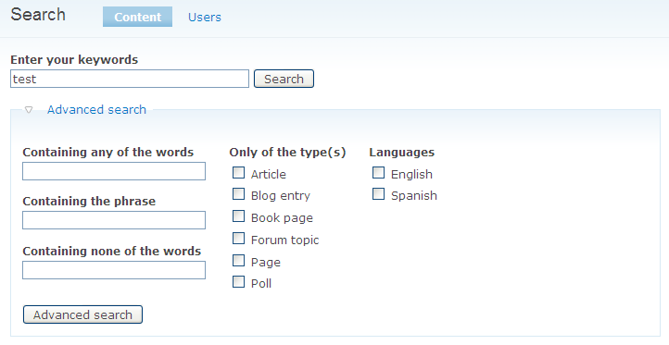

Insert image 1223\_04\_34.png

As you can see above, the advanced search page contains a section for the languages to search. If no languages are checked, all languages will be searched.

The advanced search screen is only available if you have granted a user the Use advanced search permission

# Changes to the Cron system

A common problem for new administrators is setting up cron correctly. Depending on your host and operating system, you may not have access to cron or it may be difficult to configure. Thankfully, Drupal 7 provides automated cron functionality so that cron is always running after an installation.

The settings for cron can be found in the Site information settings within the Configuration and Modules section:

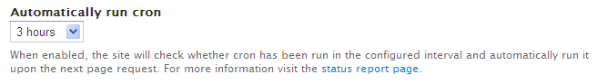

Insert image 1223\_04\_35.png

The automated cron system is triggered when a user visits your site after the cron interval has elapsed. The automated cron system is designed to work asynchronously in order to prevent performance from being impacted for the user who triggers cron. If you used Poormans cron (http://drupal.org/project/poormanscron) in Drupal 6, you will be very familiar with the Drupal 7 version.

If you prefer to use a true Unix based cron system, simply change this setting to Never and then configure cron run as usual.

## Protection from Unauthorized Access

The new Drupal 7 cron also adds protection from being run by unauthorized users. By default, cron can only be run by the first user or if you provide a special key to cron. This key is automatically generated by the automated cron system and returned to the client when cron needs to be triggered. After the key is used, it is reset to a new value.

# Reports

The Reports section contains reports about your site and the content within your site. All of the reports from Drupal 6 have been carried forward and a new Field list report has been added. The full list of reports is as follows:

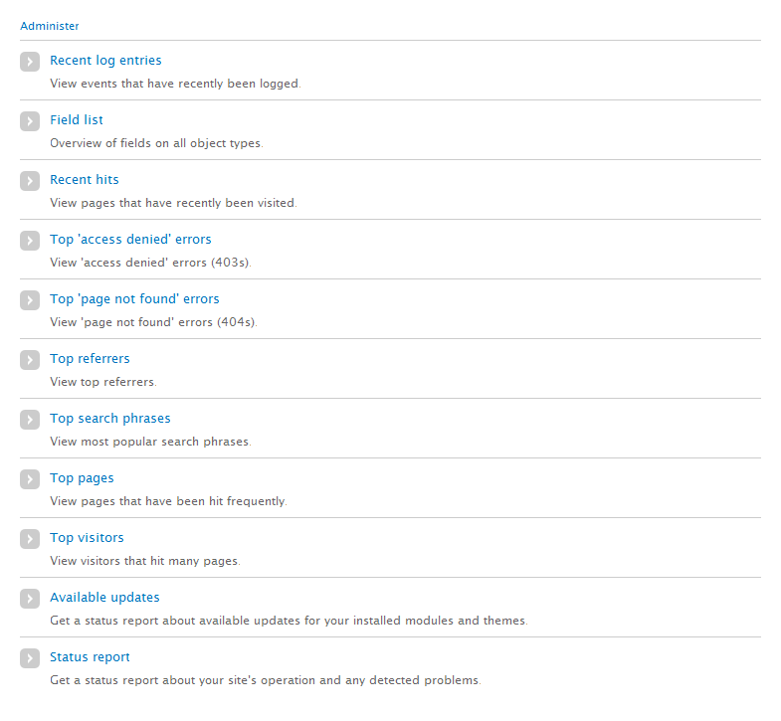

Insert image 1223\_04\_36.png

## Field list report

The field list report shows you a list of all the standard and custom fields within your site with a list of all the places where the field is used:

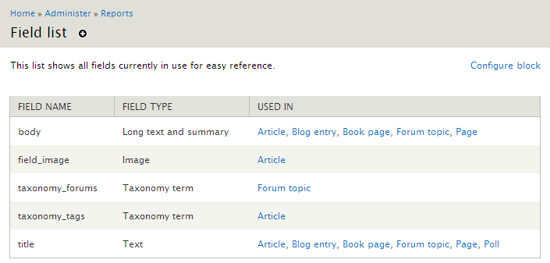

Insert image 1223\_04\_37.png

This report is very useful when you want to audit the fields on your site and determine the possible ramifications of changing field settings or deleting a field.

# Summary

In this chapter we thoroughly reviewed the new administration functionality in Drupal 7 and we mapped the Drupal 6 functionality which carried forward into Drupal 7 so you can easily find your favourite features.

In the next chapter we will explore ways to enhance both content management and the administration of your site using some of the new contributed modules in Drupal 7. We will also discuss some of the key differences between the Drupal 6 version of these modules and the Drupal 7 version. Finally, where applicable we will discuss upgrading modules from Drupal 6 to Drupal 7.